The University of Azad Jammu and Kashmir, Muzaffarabad

Name: Sakeena Bano
Roll No: 2024-SE-29
Course: DataBase Systems
Course Code: CS-2204
Lab: 01
Submitted To: Engr. Awais Rathore
Date: 4 sep, 2026

Department Of Software Engineering
Installation Of Xamp Software
Step 1: Downloading the Installer:
The process began by searching for "XAMPP download" on Google. The official website, Apache Friends (apachefriends.org), was selected to ensure a secure and authentic download of the software

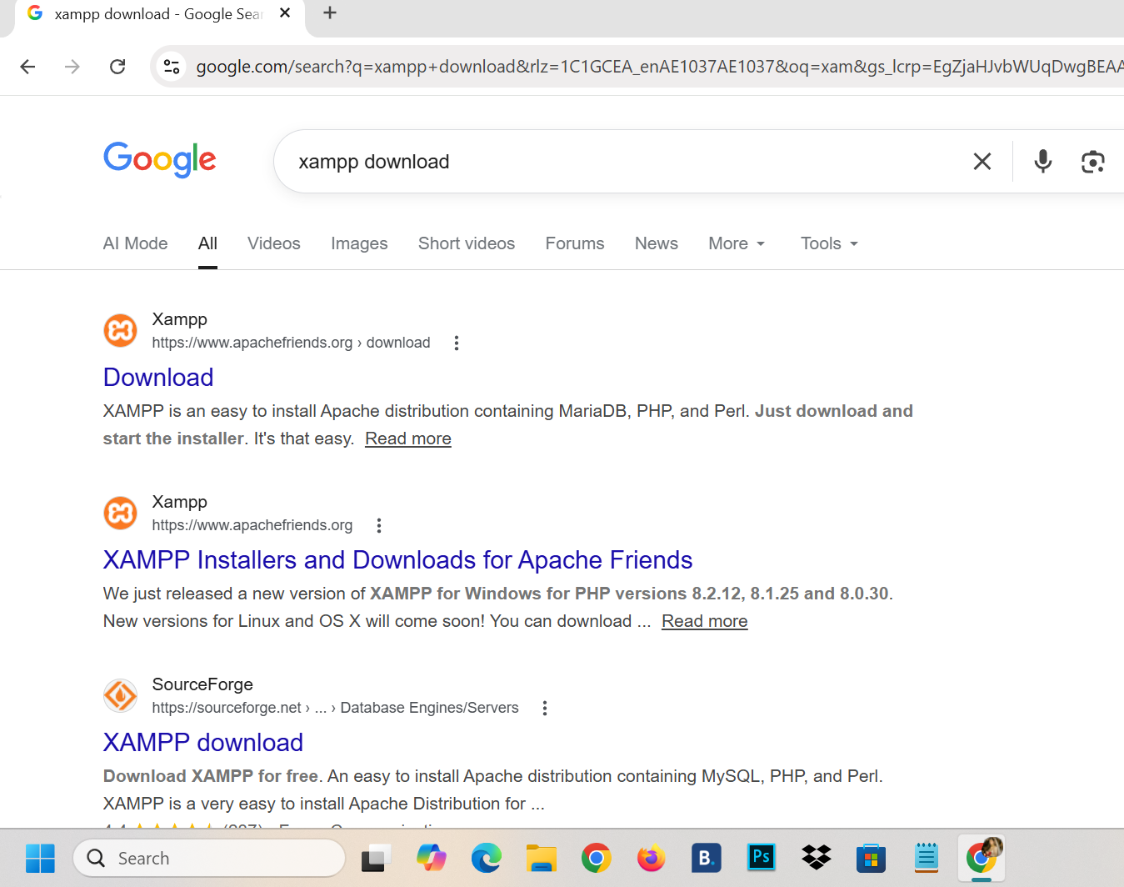

Step 2: Version Selection :
On the official download page, the version compatible with Windows was selected. For this lab, a version supporting PHP 8.x was chosen to ensure compatibility with modern web development standards.
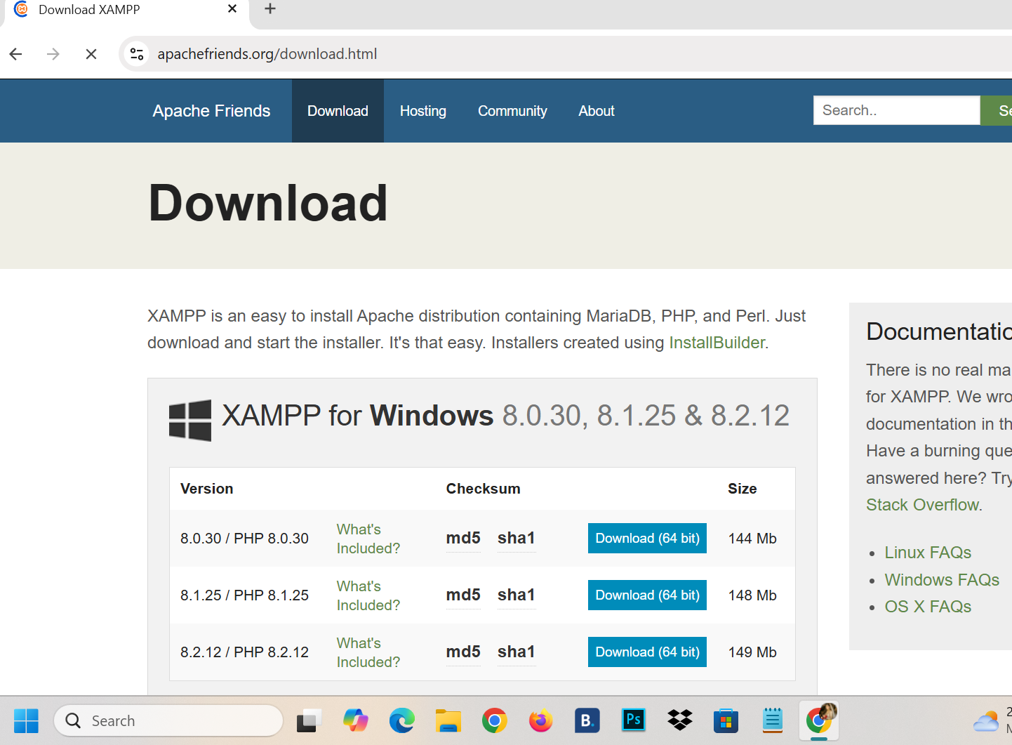

Step 3: Launching the Setup Wizard:
After the executable file (.exe) was downloaded, it was launched as an administrator. The XAMPP Setup Wizard appeared on the screen, providing a guided interface to begin the installation.
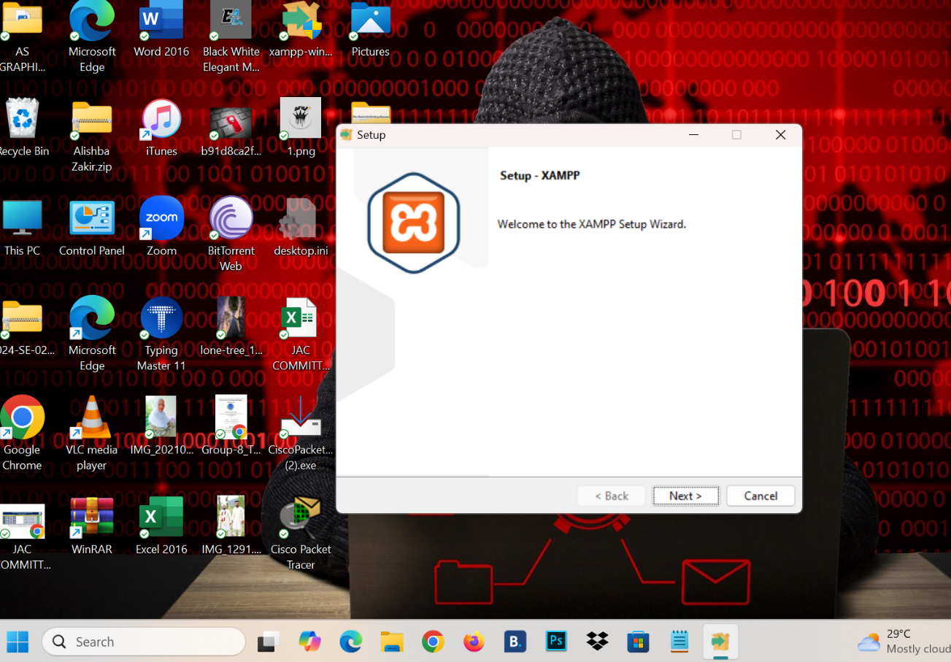

Step 4: Selecting Software Components:
During this stage, specific components were selected for installation. Essential services like Apache (Web Server), MySQL (Database), and phpMyAdmin (Database Management Tool) were checked to ensure a complete local development environment.
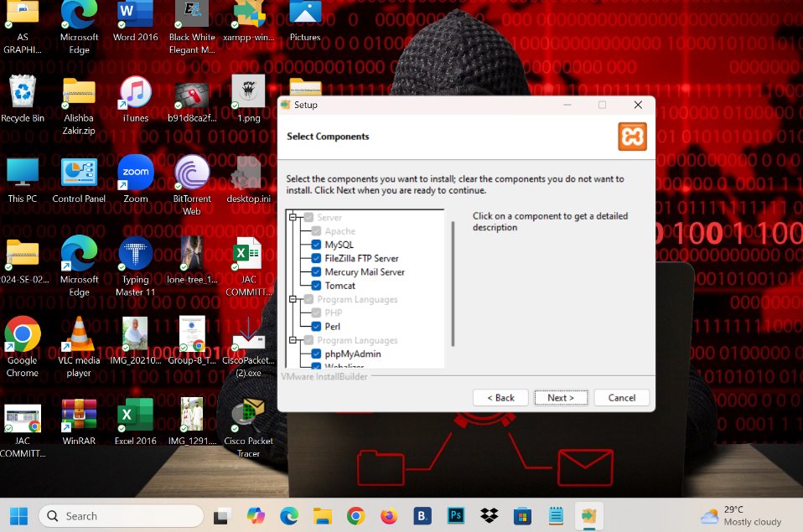
Step 5: Choosing Installation Folder:
The installation directory was set to the default path: C:\xampp. Using the default path is recommended to avoid potential permission issues within the Windows "Program Files" directory.
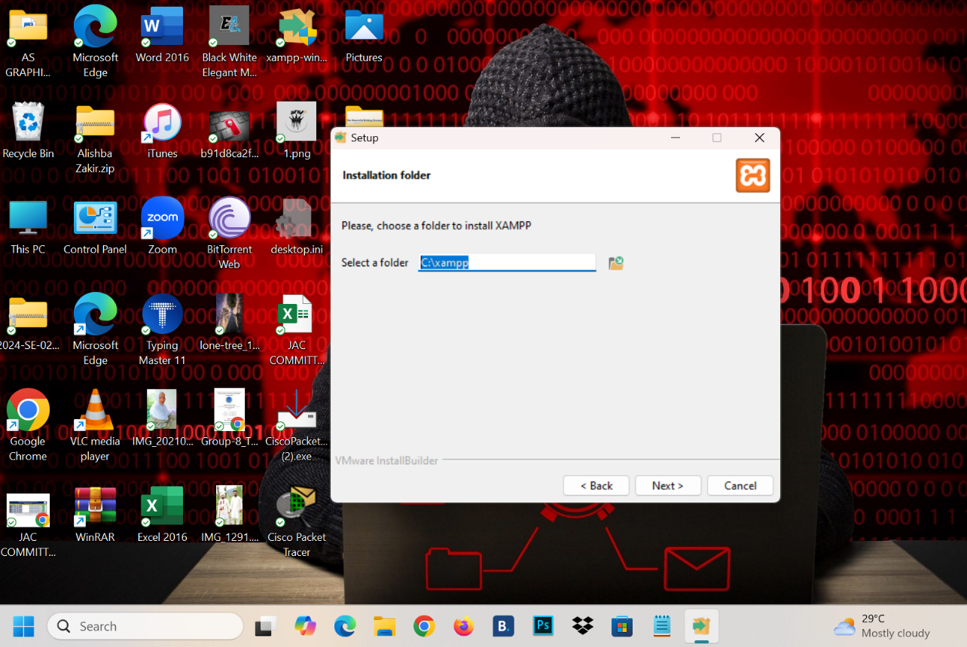

Step 6: XAMPP Control Panel Initialization:
Once the installation was finished, the XAMPP Control Panel (v3.3.0) was opened. This panel serves as the central hub to start, stop, and configure the various server modules.
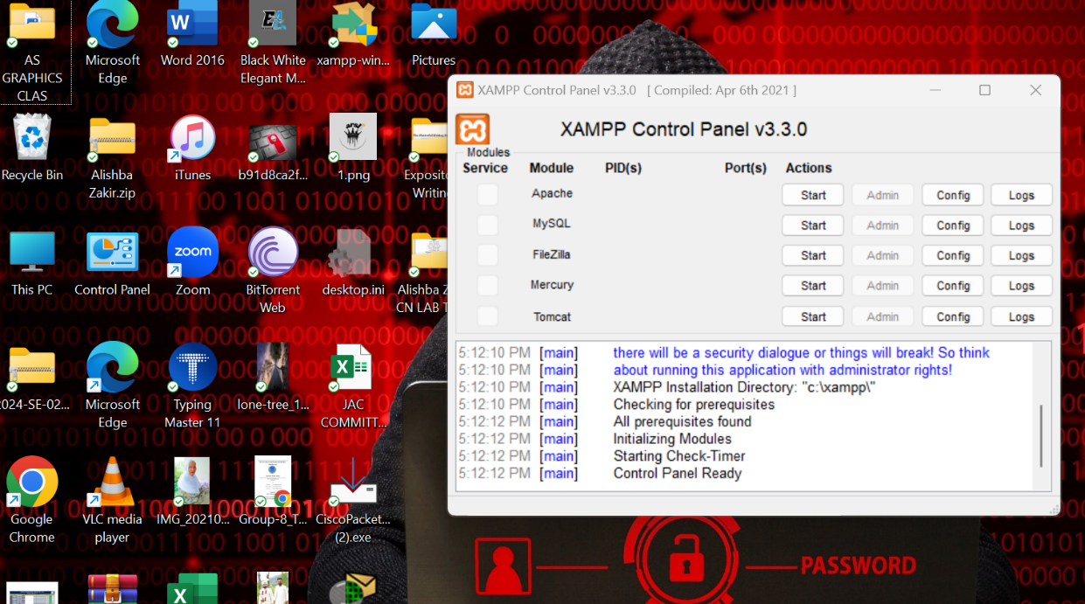

Step 7: Final Verification and Testing:
To verify that the local server was functioning correctly, the browser was directed to http://localhost/phpmyadmin. The successful loading of the phpMyAdmin dashboard confirms that the Apache server and MySQL database are installed and communicating properly.

